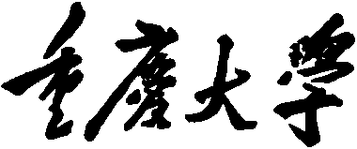


Personal Learning Portfolio

Course： English Academic Writing Teacher： Zhang Mei
Class： 001 Major： CS
Name： Student Number：
Class Time： 2024.02-2024.06
Grade：

Self | Teaching Assistant | Teacher
9

Comments：

Teacher (Signature)
Contents

Starting to Learn English Academic Writing
- My learning
- In class

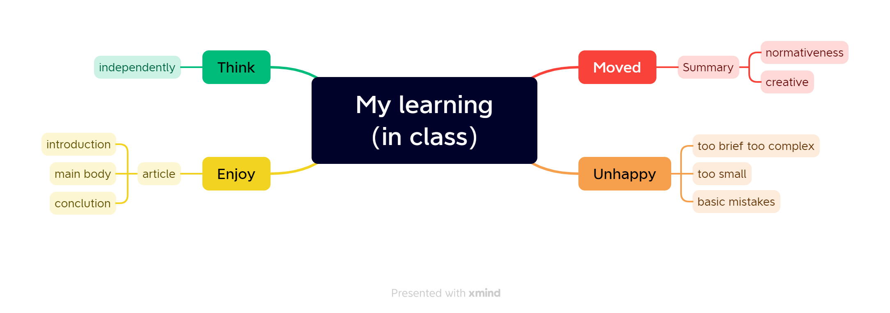
- Out of Class
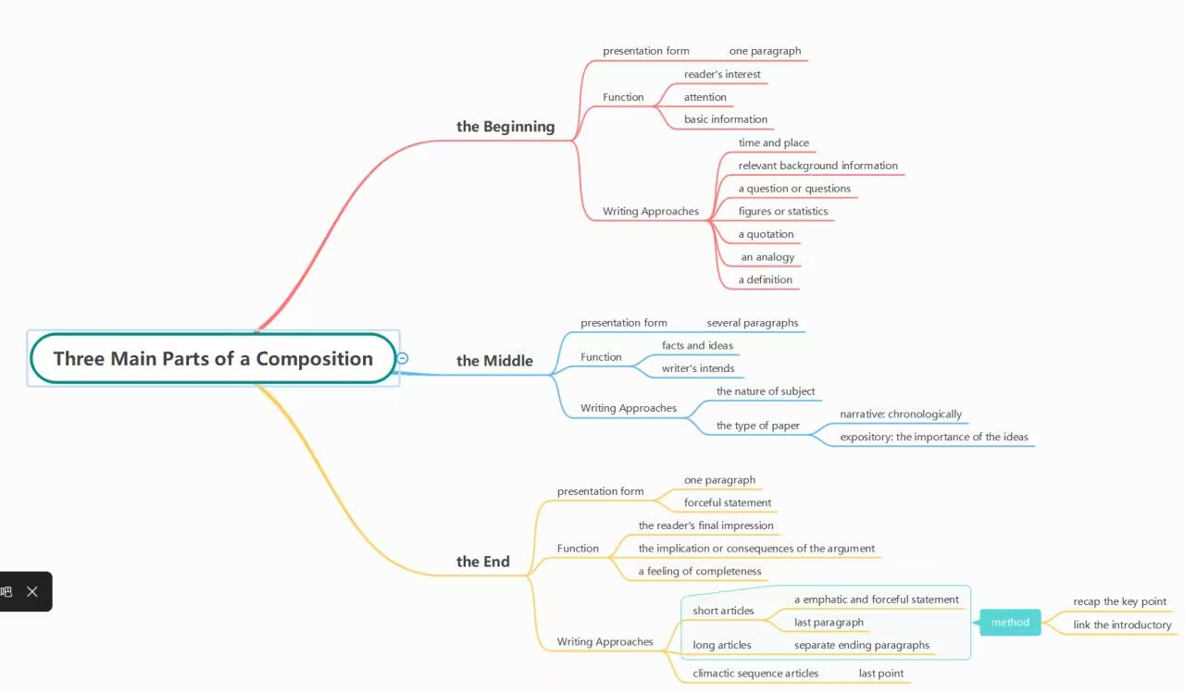

- Learning outcomes
1）In class
1) When I was in different situations, I knew how to use words at different levels.
2) When I write an article, I know that the structure in the article is: introduction, main body and conclusion.
3) For naming a file, it's important to first indicate what it is, followed by specifying who it belongs to.
2）Out of Class
1) When writing future papers, ensure the first paragraph effectively introduces background information and captivates the reader's interest.
2) When structuring the body paragraphs, arrange them logically according to the nature of the subject or the type of paper being written.
3) When concluding the paper, summarize key points or build up to a climax to provide a satisfying conclusion for the reader.
- My behavior and attitude
1）Out of Class
1.1 Autonomous learning (Online + Offline)
1.1.1 Online (CET-6 online course)
1.1.2 Offline (memorize vocabulary and listen to CET-6 listening exercises)
1.2 Homework
I completed my English assignment promptly with a diligent and meticulous attitude, ensuring it was not procrastinated until the deadline.
1.3 Cooperative learning（discuss team name）
2）In Class
2.1 Individual performance (Take notes promptly and attentively focus during class).
2.2 Cooperation (Actively participate in classroom discussions)
4．Improvement
1）Out of Class
I learned how to write specific paragraphs in the article, including the role of the beginning, middle and end paragraphs in the article.
2）In Class
This week's study started with the theme of "MUTE", in the class I learned how to summarize the mind map, master the content of the article.

